Ilan Weinschelbaum

Assignment 4

Exercise 1:

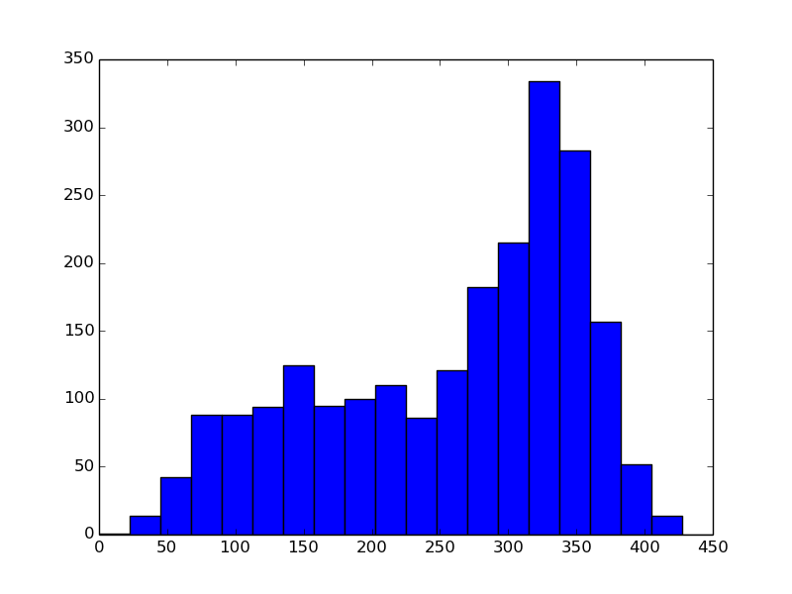

This is the histogram produced by the code for exercise one, the source code is in the file. The shape of it – having the two, fairly distinct bumps – is understandable. This is because part of the images overlap over the same region (the first, smaller bump), so the keypoint descriptors have small distances. However the rest of the images do not overlap, so they all have bigger distances, causing the second, larger bump towards the right of the histogram.

Exercise 2:

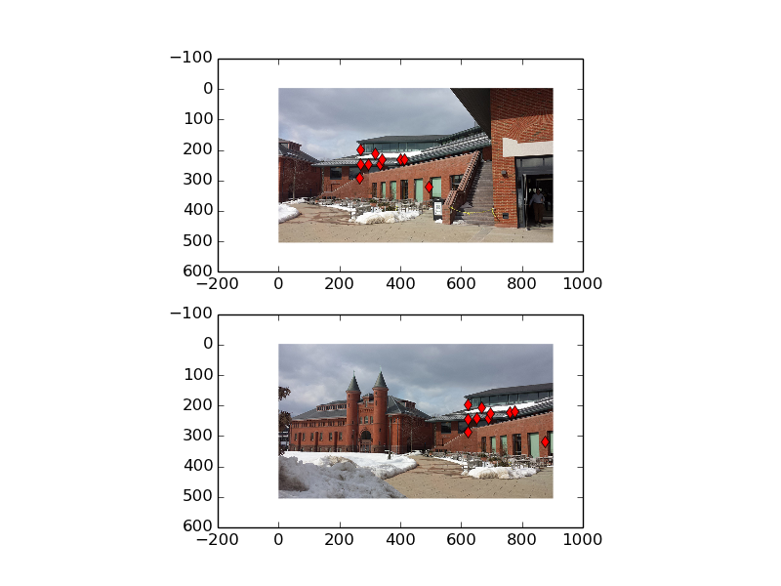

This is the image produces by the code for exercise 2, the source code is in the file. As we can see, the points line up quite nicely. This is exactly what we wanted.

Exercise 3:

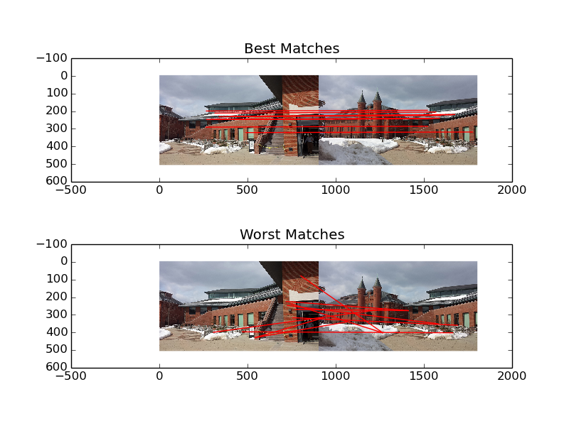

This is the output produced by the code for exercise 3, the source code is in the file. As we would hope, the best matches all sort of line up. As we would expect, the opposite is true for the worst matches – they are not the same points in the image at all.

Exercise 4:

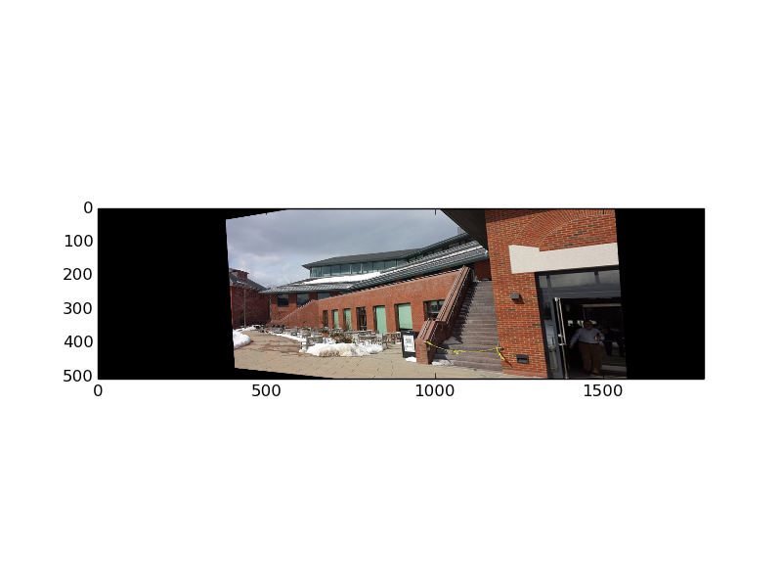

This is the original distortion to the first image. For this, I used a threshold of 463. I found this by printing the index of each entry of the sorted_matches list next to each entry, and choosing the index corresponding to the value closest to the end of the first (leftmost) bump in the histogram (at around distance = 160).

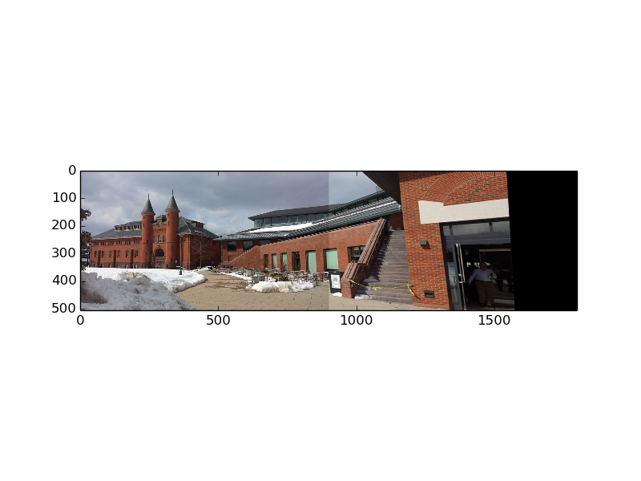

This is the final panorama image. I actually found that the line was too clear a divide at first, with the original threshold, so I used the histogram to notice that the first bump starts at about distance=100, and found that the corresponding threshold was N=170, so I used that, making the line a little less noticeable, I think. The source code in the file corresponds to this image, the final product.